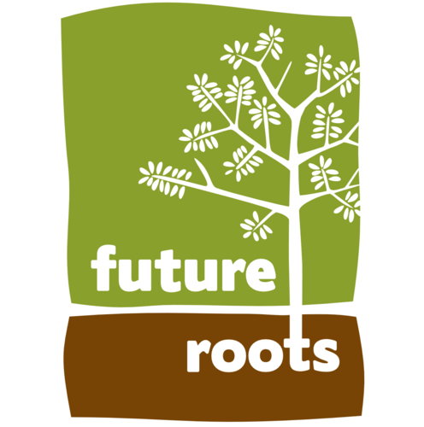

FUTURE ROOTS - Referral to the Young People’s Service 2024/25
This form is to be used for all referrals (Groups, Therapeutic Sessions, Learning Programmes and DFM)

Please complete this form as much as possible to refer an individual to Future Roots. The form (along with the Individual Profile) is designed to give us enough information to make an appropriate decision about how we may work in partnership with you and to have a clear understanding of the expected outcomes for the young person.
PLEASE NOTE: The form can be filled out electronically, saved, and emailed back to us. (Double click left to activate a check box).
About the Young Person
Name: |  | Gender: | Male Female
Likes to be Known as: |  | Likes to Identify as:
D.O.B. |  | Ethnicity:
Home Address &
Postcode:
Parent/ Carer Details: | Name: | Phone number: | E-mail:
Relationship to Young person, Parent/Carer/ Other - please specify
Is this a: Parental home Foster placement Residential Home Other Please specify? |  |  |  | Priv
Care Status | Is YP Looked After - Yes/No | Is this a Private Fostering Arrangement - Yes/No
Are there any Court Orders in place | e.g.: Special Guardianship, Care Order, Child Arrangement Order, Prohibited Steps Order
If so, please specify the Order, who has Parental Responsibility & any specific restrictions
Known allergies  e.g.: food, plant, animal, medicine  Reaction and response. |  | Current medication and administration arrangements. (Supply any guidance if available)  and administration arrangements

Do they have: Autistic Spectrum Condition Any Learning Difficulties ADHD Being Investigated?
Any other specific diagnosis:
Additional medical information: e.g. Condition and any emergency response
GP’s Name: |  | Contact no:
Address:

About their Educational Setting – School, Learning Centre, other...
Establishment: |  | E mail:
Main contact Name: |  | Telephone Contact:
Address:
 | Yes No | Free School Meals |  | Yes No
  Attending Full Time | Yes No
Perm. excluded | Yes No | Attending Part Time |  | Yes No
EHCP | Yes No | Risk of exclusion |  | Yes No
EHCP – copy attached | Yes No | Attendance (%)
Virtual School (LAC) | Contact Name: | Telephone number:
Any additional SEND information:
SEN Planning Co-ord. | Yes No | Name: |  | Number:
School Attendance Service | Name: |  | Number:

About any other services they use or have contact with.
 | Previous | Current | Name and contact no.
Children’s Social Care Services
CAMHS
Youth Offending Service
Young Carers Service
Other:

About this referral - Please Indicate the programme requested and complete all relevant sections
Category: | School Group or Farm & Animal | Small Group Nurture | 1:1 Therapeutic | DFM
Please Indicate >
Referrer/Key Worker: |  | Telephone no:
Address (if different from school)
Postcode
Referral Information /Concerns/Outcomes
School /Education:
Any behaviour or engagement concerns regarding school or learning provision?
(Please include known triggers or peer associations).
Home &Community:
Any factors regarding stability of home environment and or local community?

Behaviours:
Any risk- taking behaviours
e.g. Self-harm, allegations, physical aggression, Drug and Alcohol misuse inc. Dealing
Outcomes:
Desired outcomes: e.g. sense of belonging, relationship building, positive engagement
Qualifications:
Any learning outcomes required?
NOCN Future Farmer/
Functional Skills/ Other
Additional information available?
e.g. Relevant plans
(Care Plan/Pathway Plan, CIN Plan, PEP, CP Plan, YOS Order)

Please note:
Transport
- Future Roots do not provide transport. This remains the responsibility of the referring agency to arrange.
- When arranging Transport please ensure Young People arrive and are picked up at the agreed session times.
- Remember we do not always have staff available to supervise YP outside of their agreed session times.
Food/Lunch
- Future Roots do not provide Lunch, please ensure that when sessions span the usual lunchtimes Young People bring a suitable snack and a packed lunch.
- Drinks are however provided throughout the day.
Environment
- Future Roots is based at a farm, therefore young people will need have clothing and footwear suitable for the outdoors and weather.
- Future Roots do supply safety wellington boots which young people are expected to wear.

Referral completed by: |  | Date:

Invoice Details
Contact name: | Address & Postcode: | Contact Number: | Email:

Media and Research Release

When delivering our programme sessions at Future Roots it is important for us to monitor each student’s progress and to regularly self-evaluate our work. Photographs and other media are often collected to support this process. This includes photograph evidence for the child/young person’s learning programmes and memory books, use on our website and in a variety of other marketing materials. On rare occasions we also work with external media agencies who like to talk to students.

In each of these instances we use media images of students with discretion and in compliance with all the necessary safeguarding legislation. Where specific names and ages are required for marketing materials, we will always seek permission on an individual basis in advance of publication.

Regarding the above please indicate the photograph / media permissions below:

Media and Research Release:

Permission use photographic and media images for learning evidence and or website and marketing.

Child / Young Person’s Name:
Person from whom permission has been sought:
Relationship to YP/Child
Photos and Media for learning & course work evidence ? |  | Yes No | Photos and Media for Marketing or our Website | Yes No
Are there any specific issues relating to the use of media of this young person that you would like to tell us about?

Signed: Date:

Review date:

Thank you for taking the time to provide this information. We will try to respond to you within two weeks to tell you about our decision. Please call us on 01963 210703 if you need any further assistance.

There is CCTV at the farm for security and safety purposes and it is only viewed by Future Roots

